**10.1 Documentary Innovators Scaffold**

**Use the scaffold below to assist you with writing your speech. *What makes the documentary makers’ work innovative?***

Steps to follow:

**Innovative**: introducing new ideas; original and creative in thinking.

1. Identify the documentary (and documentary maker) that you’re going to focus your research and speech on.
2. Complete Table 1 below about features of the documentary, and how it is presented to the audience.
3. Complete Table 2 to make notes.
4. Complete Table 3 to plan and organise your information into a speech.
5. Use Table 4, for persuasive power and the cognitive verbs to help you with your vocabulary and sentence starts to ensure that you use persuasive techniques to convince your audience that the documentary maker is an innovator.

**Table 1:**

|  |
| --- |
| **Title and documentary maker:** |
| **What is the subject matter? Explain what the documentary is about.** |
| **Describe the characteristics of the style of documentary (i.e. traditional, new, subjective, objective, a narrative with an unfolding story or a collection of interviews)** |
| **What is the documentary maker’s purpose?**  **Is the documentary promoting a particular viewpoint on its subject matter?** |
| **Identify the most effective visual features the documentary maker uses and describe them.** |
| **Is the documentary maker innovative? Explain how.** |

|  |  |  |
| --- | --- | --- |
| **Table 2: Note maker Visual elements or features in the documentary – you should look for 2-3 examples per paragraph** | | |
| Visual feature used e.g. soundtrack, graphics | Example evidence (describe what happened and when in detail) | Effect/ impact on audience |
| definition: |  |  |
| definition: |  |  |
| definition: |  |  |
| definition: |  |  |
| definition: |  |  |
| definition: |  |  |

**Can you justify your choice?**

**Justify**

**Definition:** showing or proving that a decision, actions or idea about something is reasonable or necessary by giving sound, logical and reasonable reasons for it; answers the question ‘why’?

**Key words to use to justify:** although, as, as a result, because, confirm(s), consequently, corroborate, definitely, even though, however, in order to, in this situation, produce, prove(s), reinforce(s), substantiates, shows, supports, validates, There is, therefore, no doubt

**Sentence starters for justify:**

* There are many reasons for ________
* The evidence that supports the perspective that ________
* ________ is a better option because ________
* The decision to ________ is an effective response to ________
* ________ is well supported by the evidence which states that ________
* The weight of evidence suggests that ...
* Consequently,...
* The reasons that support the choice of …are solid and based on factual evidence.

**JUSTIFICATION FLOW CHART**

I am justifying that ........................ is an innovative documentary maker

**BECAUSE**

**BECAUSE**

**BECAUSE**

PROMPTS

* What are the pluses and minuses of my choice?
* Is my justification fact or opinion?
* If opinion, where is my support?
* How will I defend my decision?

**Table 3: Use this scaffold to construct your draft: due Week 7**

|  |  |
| --- | --- |
| **Essay structure** | **Your response** |
| **Introduction**   * Context: introduce your documentary with the title, documentary maker, background information, purpose of documentary (i.e. the first six rows of Table 1) * Arguments: outline the features of the documentary that demonstrate the documentary maker’s individual documentary style * Thesis: The documentary maker’s work is innovative because… |  |
| **Paragraph 1**   * *Identify*, *define* and *explain* the documentary feature(s) * *Use evidence* to *justify* the innovative nature of the filmmaker by using Table 1 (visual features) * *Evaluate* the efficacy of the feature in positioning the audience (focus on purpose of documentary) |  |
| **Paragraph 2**   * *Identify*, *define* and *explain* the documentary feature(s) * *Use evidence* to *justify* the innovative nature of the filmmaker by using Table 1 (visual features) * *Evaluate* the efficacy of the feature in positioning the audience (focus on purpose of documentary) |  |
| **Paragraph 3**   * *Identify*, *define* and *explain* the documentary feature(s) * *Use evidence* to *justify* the innovative powers of the filmmaker by using Table 1 (visual features) * *Evaluate* the efficacy of the feature in positioning the audience (focus on purpose of documentary) |  |
| **Conclusion**   * Thesis (reword it to remind readers of your contention) * Arguments (recap what you’ve stated), and *re-evaluate* the effectiveness of features to * General statement to conclude your piece and determine why the work is distinctive. |  |

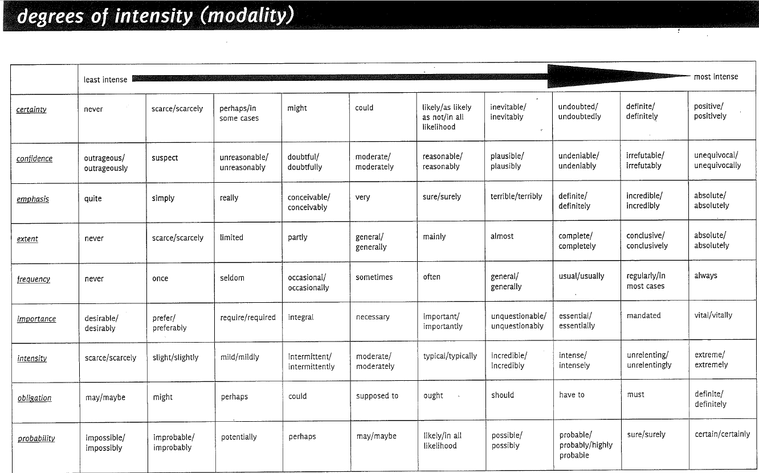

**Table 4: Cognitive verbs and metalanguage**

**Positioning:** how texts influence responders to read in certain ways. Responders are positioned or invited to construct particular meanings.

**Impacts and effects:** e.g. angered, amused, sad, disgusted, distressed, desensitised, exhilarated, fearful, surprised, anticipation, joyful, abhorrence, apprehensive, anxiety, challenged, compassionate, embarrassed, distaste, disillusioned, disturbed, intrigued, overwhelmed, traumatised, troubled, upset, thrilled

**Prompts for analysing representations:**

**Identify** the various distinguishing characteristics i.e., language, aesthetic or stylistic features in the text.

**Purpose**: Identify the author’s/ director’s perspective on the concept and their purpose.

*E.g. The documentary maker’s purpose was to…*

**Explain** how the director’s perspective is represented.

**Identify** the evidence in the text - language features (choice of film techniques) that construct a particular representation.

Break down/ **analyse** these parts.

**Explain how the effect worked e.g.**

*e.g. The choice of soundtrack is particularly evocative because it creates …*

*The effect this had was…*

*The film technique of……………… is used to illustrate the idea that …...*

**Positioning** Explain how the reader is positioned to view the concept. *With the use of … (technique) the viewer is positioned to...*

**Evaluate**  - decide whether it was skillfully/ effectively done *e.g. This was done … e.g. (*spectacularly, masterfully, cleverly, subtly).

**Evaluate:** meansconsidering something or someone to make a judgement of value or worth; often this is supported with evidence.

**Key words to use to evaluate:** effective/ineffectual, clear/ confusing, successful/unsuccessful,

**Key words to compare:** by contrast, although, apart from, by comparison, despite this,

**Key words to sum up:** especially, furthermore, nevertheless, in other respects, therefore, with regard to, the effect of, regardless, particularly

**Sentence starters for evaluating:**

* ________ is more effective/successful/appealing/distinctive than ________
* ________ evokes a feeling of ________ on the one hand, mixed with feelings of ________ on the other.
* An examination of ________ and ________ reveals that ________
* There are significantly distinct characteristics of ________, including ________
* The least distinctive feature of ________ is ________
* The most distinctive characteristic is ________ because ________. This can be seen in ________
* Even though parts of ________ are weak and indistinctive, the overall ________ is distinctive because ________
* ________ is more distinctive/successful/effective/appealing because ________
* Some would argue that ________ is more distinctive as ________

# Glossary: terms, elements of visual language in documentaries

|  |  |  |
| --- | --- | --- |
| **Element/s** | **Description** | **Purpose** |
| 1. **Social standing** | Directors may use **celebrities** or those with a high level professional **success/** experts | to link their film with that person’s **fame** or good reputation. |
| 1. **Body language** | is about **the way an actor looks and moves in a film**. Some of the things to look for include:   * **posture-**the actor's **stance**-whether it is relaxed or excited or purposeful * **facial expression**-the actor's facial expressions in advertising range from the highly exaggerated to the subtle.      * **eye contact**- breaks the fourth wall - the actor's gaze | It is an important way that producers communicate with their audience  tells you a lot **about the way the film maker wants viewers to feel about the character/ scene**  A viewer knows what an actor is meant to be feeling about the plot just by reading their face and is influenced to feel this way.  can affect the way the viewer interprets the message. If they are **looking directly at the camera**, this suggests a relationship with the viewer, as though they are **demanding a personal response** from the viewer, often used for satirical/ humorous effect in narrative film or could be to show sincerity in documentary. |
| 1. **Camera angles Perspective:** | The **'camera angle'** relates to the angle of the camera in relation to the subject. | Used to communicate setting, where the character is, then information about the characters. |
| 1. **high angle** | where the subject is filmed from above | designed to make the subject seem small. |
| 1. **eye level** | where the camera is level with the subject | designed to make the subjects seem equal |
| 1. **low angle** | where the subject is filmed from below. | designed to make the subject seem big and important |
| 1. **camera shot** | is the **distance of the camera** from the subject. The three basic camera shots: long shot, mid-shot, close-up |  |
| 1. **long shot** | where the viewer can see the subject in the context of their **surroundings**; | Establish a setting |
| 1. **mid-shot** | where the viewer can see the subject from the **waist up** | Allows you to get to know the character(s) |
| 1. the **close-up** | where the camera is **'in the face**' of the subject | used to show the actor’s emotions and influence the audience. |
| 1. **Contrast/ juxtaposition** | the placing of two or more things close together, | often as comparison or contrast for an effect |
| 1. **Framing** | A way in which elements in a still or moving image are arranged to create a specific interpretation of a whole. | Strong framing creates a sense of enclosure around elements while weak framing creates a sense of openness. |
| 1. **Editing** | footage selected by the editor | in order to tell the story in the manner chosen by the director |
| 1. **Graphics** | **graphic** representations enhance your message artistically. **Graphics** improve the quality of content, making it more appealing, interesting and thought provoking. | diagrams, graphs, pictures, and symbols. |
| 1. **Lighting and Colour** | Lighting and colours chosen  used to convey very different moods e.g. bright colours and light are often used to convey a sense of fun and happiness, while dull colours and dim lighting may be used to convey gloom and sadness.  Colours may also have specific associations. For example, red can communicate blood and danger, pink for girls, blue for boys, white for purity. | |
| 1. **Reaction shot** | Showing a character’s reaction to events or what has been said or done by another character | **Showing** the emotional **reaction** being depicted will either advance the story, reveal character traits, or emphasize character traits of another character that were displayed in the action or dialogue, to show the audience how to respond/ feel |
| 1. **satire** | Exposing and criticising the shortcomings or behaviour of an individual or a society in a text, using techniques such as exaggeration, [humour](http://literarydevices.net/humor/), ridicule and [irony](http://literarydevices.net/irony/) | To make the audience laugh, to challenge or cause a social change |
| 1. **Salience** | A strategy of emphasis, highlighting what is important in a text. In images, salience is created through strategies like placement of an item in the foreground, size and contrast in tone or colour. | **To emphasise a particular aspect in a visual** |
| 1. **Sound/ music** diegetic   Non- diegetic | words, **sound** effects, and music.   * sounds the characters can hear as well as the audience * sounds for the audience only | **Sound** is used in **film** to heighten a mood, provide us with information about the location of a scene, advance the plot, and tell us about the characters in the story  e.g. background music to enhance audience positioning. Can be used to surprise the audience |
| 1. **Special effects** | Used to create illusions. | Increasingly sophisticated software means pictures can be manipulated to create the desired message. |
| 1. **Symbols** | objects that represent other ideas. | Are used to add potent associations and meanings E.g. types of cars can represent masculinity. |
| 1. **Stylistic devices** | The ways in which aspects of texts (such as words, sentences, images) are arranged and how they affect meaning. Style can distinguish the work of individual authors (for example, Jennings’s stories, Lawson’s poems), as well as the work of a particular period (for example, Elizabethan drama, nineteenth-century novels). Examples of stylistic features are narrative viewpoint, structure of stanzas, juxtaposition. | |
| 1. **Target audience** | The target audience is the group of people considered to be the most likely consumers. | |